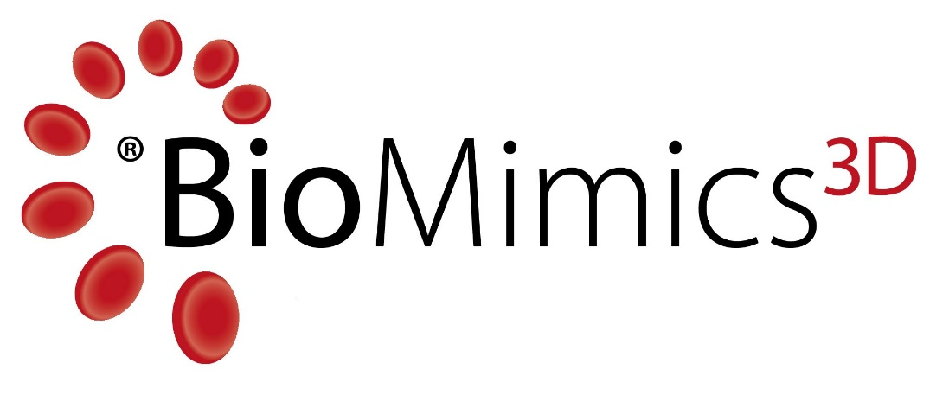

BioMimics 3D® Vascular Stent System

A Treatment for Peripheral Arterial Disease in the Superficial Femoral and Proximal Popliteal Arteries

Patient Information



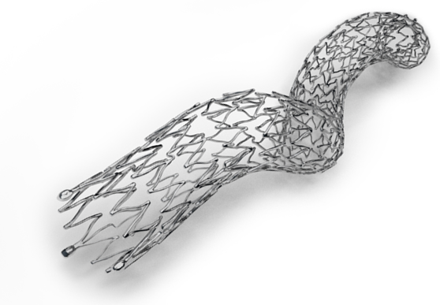

Label 016 (LBL-16 Version 5.0)
July 2025

Veryan Medical Ltd.
Block 5,
Parkmore East Business Park,
Co Galway,
Ireland
Tel: (844) 864 2001
Email: customersupportUS@veryanmed.com

Contents
1 Introduction 6
1.1 What is Peripheral Arterial Disease? 6
1.2 What Are the Superficial Femoral and Proximal Popliteal Arteries? 6
1.3 What are the symptoms of Peripheral Arterial Disease? 7
1.4 What causes Peripheral Arterial Disease? 7
1.5 What are the treatment options? 8
2 BioMimics 3D® Vascular Stent System 8
3 Stenting Procedure 9
3.1 What are the risks associated with stenting? 10
4 BioMimics 3D Clinical Data Summary 11
4.1 MIMICS -2 Clinical Study: 11
4.2 Mimics Clinical Study: 11
5 Follow-Up Examinations 12
6 Implanted Device Identification card 12
7 Magnetic resonance Imaging (MRI) 12
8 References 13

Glossary
Amputation: Surgical removal of a body part.
Angioplasty: A procedure used to open narrow arteries using a small balloon-tipped catheter. It is a minimally-invasive treatment, where a tube (catheter), with a balloon mounted on it is delivered to the diseased artery and inflated. The balloon compresses the plaque against the artery wall reducing the narrowing and increasing blood flow. The balloon is then deflated and removed.
Artery (arteries): A blood vessel that carries blood away from the heart to the tissues of the body.
Atherectomy is a minimally-invasive procedure using a catheter to cut or abrade the atherosclerotic deposits, thus opening the channel for blood flow.
Atherosclerosis: A disease process involving the build-up of a fatty substance called plaque on the inside of the arteries.
Blood vessel (vessel): An artery or a vein.
Bypass surgery: See Open bypass.
Bypass graft: A fabric tube or blood vessel taken from another part of the patient’s body used to bypass a blockage and restore blood flow.
Catheter: A thin, hollow tube that is inserted through a small opening in the body.
Claudication: Leg pain, cramping, or severe tiredness while exercising.
CT scan: A scan that uses X-rays to see inside the body.
Delivery catheter: A catheter used to implant a device, such as a stent.
Endovascular: Inside or within a blood vessel.
Endovascular repair: A procedure in which a vessel is treated from the inside.
Femoral artery: Artery that carries blood from the pelvis to the leg. Doctors can use this artery as a path to reach other arteries such as the iliac, superficial femoral and popliteal arteries.
Guidewire: A thin floppy wire used to cross the narrowing or occlusion in the vessel
Hematoma: A pocket of clotted blood that forms in tissue.
Hypertension: High blood pressure.
Hypotension: Low blood pressure.
Imaging: The use of X-rays, CT scans, MRI scans, ultrasound, or other techniques to get pictures of the inside of the body.
Infection: Disease of tissue due to the presence of tiny organisms, such as bacteria.
Lumen: The central space in an artery through which blood flows.
Minimally invasive: Involving a small cut of the skin without exposing the organs.
Magnetic Resonance Imaging (MRI): A technique that uses magnetic fields to get pictures of the inside of the body.
Occlusion: A complete blockage of a blood vessel.
Open surgical repair / surgical bypass: An open surgical repair in which a surgeon uses either a fabric tube (graft) or a blood vessel taken from another part of the patient’s body to redirect blood around a narrowed or blocked artery and restore blood flow. The bypass is performed by sewing the bypass graft to arteries above and below the diseased vessel.
Patent: the proportion of the lumen of the artery that is open for blood flow is 50% or more
Percutaneous Transluminal Angioplasty (PTA): See Angioplasty
Peripheral Arterial Disease (PAD): Atherosclerosis of the peripheral arteries, such as arteries of the pelvis and legs.
Plaque: Build-up of fat and cholesterol on the inner lining of arteries.
Popliteal artery: A continuation of the superficial femoral artery that crosses behind the knee to carry blood to the lower leg.
Restenosis: Re-narrowing of a vessel at the site of treatment.
Spasm: Narrowing of an artery due to contraction of the muscle cells.
Stenosis: A narrowing on the inside of a vessel.
Stent: A metallic mesh tube that is permanently placed in the vessel to support an artery and restore blood flow.
Stenting is a minimally invasive procedure, in which a stent (metallic mesh tube) is permanently placed inside the artery. This acts as a support to the artery to keep the diseased artery open and maintain increased blood flow. The stent is delivered to the artery inside a catheter that is removed once the stent is deployed. Over time, the artery will heal around the stent as it continues to support the artery.
Stent fracture: Breakage of the stent, or individual struts of the mesh tube, within the artery.
Strut: An element of the mesh tube that forms the stent structure
Superficial Femoral Artery: Artery in the thigh that carries blood to the knee and lower leg. The superficial femoral artery transitions to the popliteal artery near the knee.

Introduction
This guide is intended to help you understand the treatment of peripheral arterial disease in the superficial femoral artery and proximal popliteal artery and to provide you with specific information about the BioMimics 3D Vascular Stent System.
If you are unsure of the meaning of any terms used in this guide, consult the glossary on page 4 and 5.

What is Peripheral Arterial Disease (PAD)?
PAD is a circulatory problem caused by the presence of atherosclerosis in peripheral arteries. The term peripheral arteries refer to all arteries except for the arteries in the heart and brain. Atherosclerosis occurs when the arterial walls become damaged by a build-up of fatty substances, fibrous tissue and calcium, which then reduces blood flow through the artery.

What Are the Superficial Femoral and Proximal Popliteal Arteries?
The superficial femoral artery starts at the groin and extends down to just above the knee. The superficial femoral artery connects with the popliteal artery, which runs behind the knee. The popliteal artery then branches into smaller arteries that supply oxygen-rich blood to the calves and feet (see Figure 1).
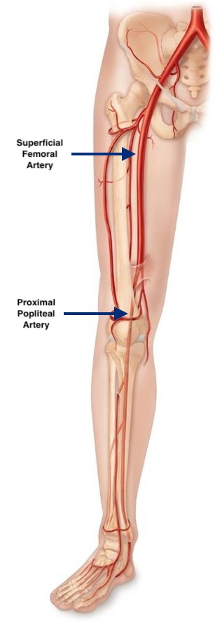
Figure 1: Arteries of the leg

What are the symptoms of Peripheral Arterial Disease?
There are a range of symptoms associated with PAD which include:
- Pain, discomfort or tiredness in the legs when walking, known medically as claudication;
- Pain in the foot, particularly at night, eased when lowering the foot out of bed (rest pain); and ultimately, as PAD progresses to Ulceration and gangrene of the toes and feet.
In the early stages of PAD, there may be no symptoms. In mild PAD, reduced blood flow may cause pain in the muscles when walking, which may be eased with rest (claudication). In severe cases, there may be pain at rest, with skin ulcers and infections of soft tissue causing gangrene as PAD worsens.

What causes Peripheral Arterial Disease?
PAD develops over time with the accumulation of atherosclerotic deposits in the vessel wall, which limits blood flow.
Factors associated with the development of PAD are:
- smoking
- obesity
- diabetes
- high cholesterol
- high blood pressure
- renal failure
- inherited tendency

What are the treatment options?
There are a range of treatment options depending on the stage of PAD.
For mild symptoms, your physician may advise lifestyle changes such as stopping smoking, exercising regularly, reducing fat and cholesterol in your diet, and keeping your blood pressure under control.
Your physician may also prescribe medication to lower cholesterol and make cells in your blood less sticky (e.g. aspirin or clopidogrel).
For more severe symptoms or those that have not improved after lifestyle changes, your physician may advise a minimally-invasive procedure carried out through a small cut in the skin, usually in the groin, to gain access to the arteries. Using this route, the physician may use angioplasty or atherectomy to open the blockage, both of which are commonly accompanied by placing a stent, or scaffold, to keep the vessel open. This guide specifically looks at this treatment option. If the PAD is widespread, then the physician may advise an open surgical procedure such as bypass surgery, so that blood can flow around the blockage and down to the arteries of the lower leg.

BioMimics 3D® Vascular Stent System
The BioMimics 3D Vascular Stent System consists of a self-expanding stent that is loaded into a delivery catheter. The stent is made from a special alloy of nickel and titanium, called nitinol, that can store a specific shape within its memory, so that once the stent is released from the catheter it will provide just the right amount of support to the vessel in which it is placed. Arteries naturally have a helical shape which leads to naturally-occurring swirling blood flow in vessels [1] which prevents the build-up of fatty substances, fibrous tissue and calcium. Stents are usually straight mesh tubes (Figure 2). The BioMimics 3D Stent has been developed with a unique three-dimensional helical shape (Figure 3) which mimics the natural curvature of the human vascular system. This helical shape enables the stent to shorten with the vessel as the knee/hip is bent.

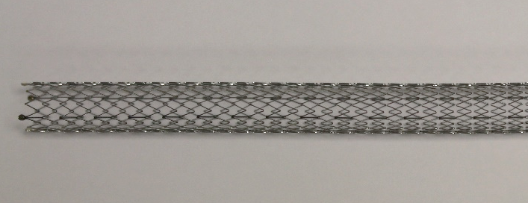 | 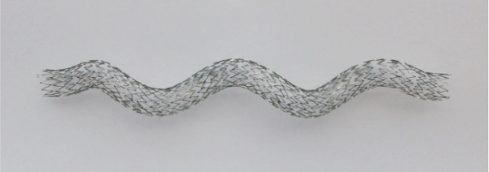
Figure 2: Straight stent | Figure 3: BioMimics 3D helical stent

Stenting Procedure
After making the skin numb with local anesthetic, your physician will gain access to an artery through a small incision, usually in your groin. A guidewire will be inserted and passed across the narrowed section in your artery.
Prior to inserting the stent, the physician may use an angioplasty balloon or atherectomy device to expand the narrowed region of the artery. The BioMimics 3D stent is supplied already loaded inside the delivery system and may be inserted over the same guidewire. The stent is deployed permanently in the treated artery to keep it open.
After the stent is implanted, the stent delivery system is removed, and the physician may choose to inflate a balloon within the stent to open it further. Once all procedures are complete, the guidewire is removed from the body and the puncture in your groin is then closed.

What are the risks associated with stenting?
Your physician may not consider you to be a good candidate for stenting if you have any of the following conditions:
- You have a history of intolerance or adverse reaction to antiplatelet and/or anticoagulation therapies and bleeding diathesis,.
- You have a known hypersensitivity to nickel or titanium.
As with all procedures that introduce a catheter into an artery, complications may occur. These complications include, but are not limited to:
- Stent system events: Device embolization; device malfunction; serious injury or surgical intervention; stent strut fracture(s); stent migration; stent misplacement/jumping.
- Vascular events: aneurysm; arterial dissection; arterial perforation; arterial rupture; arterial spasm; arteriovenous fistula; embolism and/or arterial thrombosis; hematoma; hypotension; ischemia; vascular complications which may arise during placement of a bailout stent; pseudoaneurysm; restenosis of the treated segment; stenosis; total occlusion of the peripheral artery; abrupt occlusion of the peripheral artery; vascular complications which may require surgical repair (conversion to open surgery) or endovascular intervention; worsening of peripheral arterial disease leading to additional surgical intervention, endovascular intervention or amputation; vasospasm.
- Bleeding events: Access site complications including bleeding or hemorrhage; gastrointestinal bleed; bleeding complications requiring transfusion.
- Procedural events: Allergic reaction to contrast media / medications; extravasation of contrast media; fracture of the guidewire or any component of the BioMimics Vascular Stent System that may or may not lead to device embolism; radiation exposure.

- Angina
- Bradycardia
- Cardiac arrest
- Cardiac arrhythmia
- Death
- Emergency or non-emergency arterial bypass surgery
- Infection or fever
- Leg pain/claudication
- Myocardial infarction or coronary ischemia
- Nausea/vomiting
- Neurological deficit
- Renal insufficiency or failure
- Respiratory distress or failure
- Serious injury requiring surgical intervention
- Stroke or transient ischemic attack

BioMimics 3D Clinical Data Summary

MIMICS-2 Clinical Study:
The safety and effectiveness of the unique helically-shaped BioMimics 3D Vascular Stent System was evaluated in the MIMICS-2 Clinical Study, which studied 271 patients who were followed up for 36 months after receiving the stent. Safety is evaluated by looking at the number and type of any adverse events that have taken place at 30 days and 12 months after implant. An adverse event is any untoward medical occurrence that occurs in a patient even if it is not necessarily due to the implant or the procedure. A major adverse event is defined as death, repeat intervention in the lesion where the stent was placed, and/or major amputation. In this study, a major adverse event occurred in 1 out of 269 patients (0.4%) at 30 days and in 35 out of 261 patients (13.4%) at 12 months. These results show that patients who received the BioMimics 3D Vascular Stent System had a rate of major adverse events similar to that which has been reported for comparable patients in similar studies.
In general, following angioplasty or stent implantation, there is a tendency for the artery to re-narrow in some patients. The effectiveness of the stent is measured by its patency (i.e. whether the stented blood vessel is patent or not). This was assessed by an independent laboratory, which reported 73.1% (182/249) of the BioMimics 3D stents were patent at 12-months, without having needed any further intervention.
The MIMICS-2 Study included an additional outcome assessment at the end of the 3rd year of follow-up. Independent clinical review of the subsequent need for reintervention in patients treated with the BioMimics 3D stent, revealed a freedom from reintervention rate of 79.9%. This is consistent with rates of re-intervention reported for comparable patients in recent clinical studies with other current stent technologies.
Patients’ clinical symptoms due to PAD were assessed throughout the MIMICS-2 study and a sustained clinical benefit was evident in patients treated with the BioMimics 3D Stent.
Core laboratory review of X-ray imaging of the treated area concluded that there was no evidence of any BioMimics 3D stent fracture in any image reviewed from patients at 12, 24 or 36-month visits.

Mimics Clinical Study:
Safety and performance of the unique helically-shaped BioMimics 3D Stent were assessed in the Mimics Study using a straight nitinol control stent as a comparator. A total of 60 subjects treated with a total of 61 BioMimics 3D stents, were completely free of major adverse events through 30 days, including death, treated limb amputation or the need for further intervention to the area of vessel narrowing. This met the primary safety outcome measure of the Mimics Study. After 6 months of follow up, no subject treated with the BioMimics 3D stent in the Mimics Study required further intervention to the treated area of narrowing due to recurrence of symptoms. Analysis of data from the follow-up period through 24 months showed that the proportion of patients treated with BioMimics 3D with stent patency at 12 and 24 months was 75% and 72% respectively. There was independent clinical review of the subsequent need for reintervention in both patient groups. This revealed a freedom from reintervention rate of 91% for those patients treated with the BioMimics 3D stent vs. 92% for those receiving the control stent at 12 months. At 24 months the freedom from reintervention rate for BioMimics 3D and control stent was 91% versus 76%. Thus, there was no need for re-intervention in patients treated with the BioMimics 3D stent between the 1 Year and 2 Year time points.
Core laboratory review of X-ray imaging of the treated area revealed no stent fracture in any BioMimics 3D stent through 24 months of follow-up.

Follow-Up Examinations
Regular follow-up visits will be scheduled with your physician to check on you and your stent. These are important to attend, so that your physician can monitor your progress and see how the stent is working for you.

Implanted Device Identification Card
After your procedure, your physician will give you an implanted device identification card. This card provides information about the stent you have received.
It is important to keep this card with you always and to present it in the event of an emergency as it identifies you as a patient who has a stent implanted.

Magnetic Resonance Imaging (MRI)
It is safe to have MRI procedures after being implanted with a BioMimics 3D stent, under certain conditions. The BioMimics 3D Stent has been classified as ‘MR Conditional’, which means that an MRI can be done safely under specific testing conditions. Present your implant card and/or this patient Information leaflet to your physician so he/she can identify the MRI conditions that are appropriate for your BioMimics 3D stent.


MR Conditional
Non-clinical testing has demonstrated that the BioMimics 3D stent is MR Conditional in single and overlapped configurations. A patient with the BioMimics 3D stent can be scanned safely under the following parameters/ conditions of use:
Parameter | Condition of use/Information
Device Name | BioMimics 3D Vascular Stent System
Static Magnetic Field Strength (B₀) | 1.5 T, 3 T
Static Magnetic Field Strength (B₀) Orientation | Horizontal, Cylindrical Bore
Maximum Spatial Field Gradient (SFG) | 4,000 Gauss/cm (40 T/m) or less
RF Polarization | Circular Polarized (CP)
RF Transmit Coil | Integrated Whole Body Transmit RF coil
RF Receive Coil | Any receive coil may be used
MR System (RF) Operating Modes or constraints | Normal Operating Mode
Whole-body Averaged SAR | Normal Operating Mode 2 W/kg
Maximum head SAR | Normal Operating Mode 3.2 W/kg
Scan Duration and wait time | 15 minutes of continuous RF exposure (a sequence or back-to-back series/scan without breaks) followed by a wait time of 5 minutes before resuming scanning.  Note: Auto scanning/ Auto-scan Mode is considered continuous scanning. Short pauses between scan sequences are considered part of the scan time.
MR Image Artifact | In non-clinical testing, the image artifact caused by the device extends approximately 12.8 mm from the BioMimics 3D stent when imaged with a spin echo pulse sequence and a 3 Tesla MRI System. The artifact partially obscures the device lumen.
Scanning under different conditions may result in injury/device malfunction.
MRI Safety information may be found at https://veryanmed.com/ePIL

References
[1] C. G. Caro et al., “Intimal hyperplasia following implantation of helical-centreline and straight-centreline stents in common carotid arteries in healthy pigs: influence of intraluminal flow,” J R Soc Interface, vol. 10, no. 89, p. 20130578, Dec. 2013.

